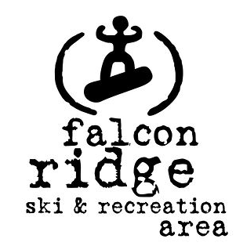



**Race Notice**: **The Falcon Combined Jan. 30th and Jan. 31st 2016**

***A two-day competition of Nordic Skiing and Biathlon at Falcon Ridge***

**CCSAM Manitoba Cup Race #5**

**+ Biathlon Open House**

**Day 1: Saturday, January 30th 2016**

**Technique:** Free

**Date:** Saturday, January 30th

**Registration Deadline:**  Jan. 27th at 10pm on [Zone4](http://new.zone4.ca)

**Hosts:** Hosted by [Red River Nordic](http://redrivernordic.ca) at Falcon Ridge

**Contacts:**

* Chief of Competition Chris Roe [croe@pembinatrails.ca](mailto:croe@pembinatrails.ca)
* Chief of Course Doug Smith dougsmith200@gmail.com
* Competition Secretary Ron Pelletier skinnyskis@me.com
* Canadian Nordic Ski Patrol Brian Barton 204-783-1744

**Location Day 1 and Day 2: Falcon Ridge *Ski and Recreation Area*.** [**Falcon Ridge link here.**](http://falconridgeski.com)

Located on the shore Falcon Lake in the Manitoba’s Whiteshell Provincial park, Falcon Ridge offers beautiful views of the lake amidst a woodland Boreal Forest setting. Falcon Ridge has over 25 km of maintained x-country ski trails connecting to the local Trans-Canada trail, and Provincial Park maintained West Hawk ski trail circuit which has endless kilometers of wilderness to explore. There are trails groomed for both classic (track set) and skate skiing.

**Driving Directions + Accomodations: How to get to Falcon Ridge Ski Area. Click here.[Click here.](https://www.google.ca/maps/place/Falcon+Ridge+Ski+Slopes/@49.7037737,-95.1925701,17z/data=!3m1!4b1!4m2!3m1!1s0x52be32da76a13aa3:0xe3cd7688541abc56)**

Falcon Ridge Ski Hill is located on the south-east end of Falcon Lake in the Whiteshell Provincial Park in Manitoba. To get there, turn off the #1 highway at Falcon Lake, about 7 minutes west of the Manitoba/ Ontario border. Once you've turned off the highway, follow the south shore road (past the golf course, the lumber yard and the marina) for about 15 minutes. Falcon Ridge is located right at the end of this road. Falcon Ridge is a 90 minute drive east from Winnipeg, and 45 minutes west of Kenora, Ontario. **Accommodations**: Falcon Ridge Resorts located in [Falcon Ridge link here](http://www.falconridgeski.com). There are numerous accommodations in [Kenora links here](http://www.tripadvisor.ca/Hotels-g181749-Kenora_Kenora_District_Ontario-Hotels.html).

**First Aid:** First Aid will be available on site courtesy of the Canadian Ski Patrol

**Day 1: Saturday, January 30th 2016**

**CCSAM Manitoba Cup Race #5 @12 pm**

**and Biathlon Open House @2:30 pm**

|  |  |
| --- | --- |
| * Fri., January 29th @Midnight | Official Race Lists posted on Zone 4 |
| * Sat., January 30th @10:30 am | Bib pick up in the Falcon Ridge Chalet and all courses open for pre-skiing |
| * Sat., January 31st @11:00 am | Coaches’ meeting in the Falcon Ridge Wax Hut |
| * Sat., January 31st @12:00 pm | Mass Starts (Free Technique) in waves |
| * Sat., January 31st @2:00 pm | Awards in the Falcon Ridge Chalet |
| * Sat., January 31st @2:30 pm | Biathlon Open House --- at the Biathlon Range  Come experience Biathlon shooting. Ages 11 + |

**CCSAM Competitive Age Categories**

Your competitive age category is based on how old you are**as of December 31st** in the *current competitive season*. For example, in 2015 – 2016 your age as of December 31, 2015 is your age for the entire 2015 – 2016 competitive season. Our Competition Model makes it possible for young skiers to compete in categories that are a better match for their *development age* if not their chronological age. For example, a Midget aged skier may race as a Juvenile whenever the athlete, their parents and coach together determine that to be the most appropriate competitive category. **Skiers wanting to race in a category other than their competitive age category must notify Ron Pelletier, the competition secretary by e-mail by Jan. 27th at 10pm.**

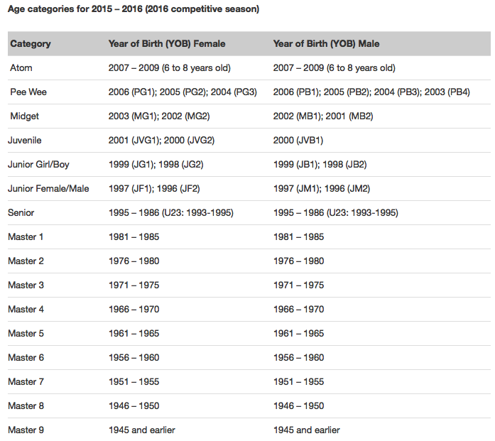

**Day 1: Saturday, January 30th 2016**

**CCSAM Manitoba Cup Race #5 @12 pm**

**and Biathlon Open House @2:30 pm**

**Race Distances:** [Course Maps: linked here.](http://biathlonmanitoba.ca/news/map/facilities-trails/)

|  |  |  |  |
| --- | --- | --- | --- |
| **Sat., Jan. 30th 2016**  **Free Technique Distances** | | **Mass Start Waves starting @12:00 pm at the Falcon Ridge Chalet** | |
| Category | Distance (km) | Mass Start Wave | Course |

|  |  |  |  |
| --- | --- | --- | --- |
| Para Nordic  Men Sitski | 2.5 | #1 | Brown |
| Para Nordic  Women: Sitski | 2.5 | #1 | Brown |

|  |  |  |  |
| --- | --- | --- | --- |
| Pee Wee Boys | 2.5 | #2 | Brown |
| Pee Wee Girls | 2.5 | #2 | Brown |
| Midget Boys | 5 | #2 | Brown x 2 |
| Midget Girls | 5 | #2 | Brown x 2 |

|  |  |  |  |
| --- | --- | --- | --- |
| Para Nordic  Men Standing | 5 | #3 | Brown x 2 |
| Para Nordic  Women Standing | 5 | #3 | Brown x 2 |

|  |  |  |  |
| --- | --- | --- | --- |
| Junior Men | 15 | #4 | Red x 3 |
| Junior Women | 15 | #4 | Red x 3 |
| Senior Men (U23) | 15 | #4 | Red x 3 |
| Senior Women (U23) | 15 | #4 | Red x 3 |
| Masters Men | 15 | #4 | Red x 3 |
| Masters Women | 15 | #4 | Red x 3 |

|  |  |  |  |
| --- | --- | --- | --- |
| Juvenile Boys | 5 | #5 | Red x 1 |
| Juvenile Girls | 5 | #5 | Red x 1 |
| Junior Boys | 10 | #5 | Red x 2 |
| Junior Girls | 10 | #5 | Red x 2 |

* Distances and courses are subject to change due to conditions.

**Eligibility**

All competitors from Juvenile and up must have a valid CCC race license or hold a CCC supporting member (day license) in accordance with CCC Document 2.2.2 – Race License Policy. Day Licenses are to be purchased on the Zone 4 registration page for a fee of $5.00/day.

**Saturday only Race Fees**

* Pee Wee, Midget + Juvenile Boys/Girls + Junior Boys/Girls Categories $15.
* All Men’s/Women’s Categories $20

Race Fees for skiers competing on both days receive a $5 discount off the two-day race fee total.

**Day 2: Sunday, Jan. 31st 2016**

**Biathlon Manitoba Cup Race @12 noon**

**Format: Individual Race - time penalty for missed targets (skate ski technique)**

**Date:** Sunday, Jan. 31st 2016

**Registration Deadline:**  at Jan. 27th at 10 pm on [Zone4](http://new.zone4.ca)

**Hosts:** Hosted by Biathlon Manitoba

**Contacts:**

* Chief of Competition Lin-P’ing Choo-Smith choosmith@gmail.com
* Chief of Course Jim Kovachik [kovachik@mymts.net](https://pembinatrails.ca/owa/?ae=Item&t=IPM.Note&a=New&to=kovachik%40mymts.net&nm=kovachik%40mymts.net)
* Competition Secretary Ron Pelletier skinnyskis@me.com
* Chief of Range Barry Mitchell bgmitchell@shaw.ca

|  |  |
| --- | --- |
| * Thursday, Jan. 27th @10pm * Fri., Jan. 29th @Midnight | Registration Deadline on Zone 4  Official Race Lists posted on Zone 4 |
| * Sun., Jan. 31st @10:00 am – 10:30 am | Bib pick up in the Falcon Ridge Chalet and all courses open for pre-skiing |
| * Sun., Jan. 31st @ 10:00 am – 10:15 am | Coaches’ meeting in the Falcon Ridge Chalet |
| * Sun., Jan. 31st @10:30 am – 11:30 am | Rifle Zeroing |
| * Sun., Jan. 31st @ 12 noon | Races begin |
| * Sun., Jan. 31st @ 2:30 pm or upon race conc. | Awards in the Falcon Ridge Chalet |

**Biathlon Race Distances:** [Course Maps: linked here.](http://biathlonmanitoba.ca/news/map/facilities-trails/)

* Distances and courses are subject to change due to conditions.

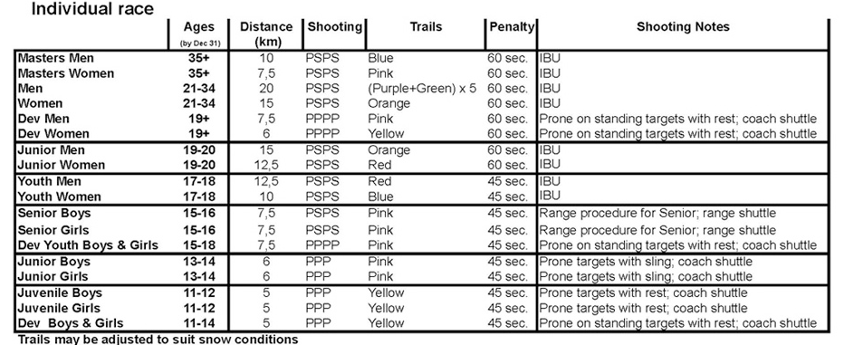

**Sunday Only Race Fees**

* Youth Men + Women, all Boys and Girls categories $15
* All Men’s/Women’s and Masters categories $20

Race Fees for skiers competing on both days receive a $5 discount off the two-day race fee total.







**Eligibility:** All competitors must be a member of a Biathlon Canada club or purchase a ‘Day Licence’ on the Falcon Combined Zone 4 registration page.

**Registration Deadline**

Registration is to be completed only through Zone 4 at <http://www.zone4.ca>. The deadline for registration is Jan. 27th at 10 pm. **NO LATE REGISTRATIONS WILL BE ACCEPTED.**

Entry fees include healthy snack foods, drinks, and fruit for athletes and coaches.