Race Notice Grand Beach Classic
Manitoba Cup Race #1
Technique: Classic
Dates: Saturday Dec. 21st to Sunday Dec. 22nd
Registration Deadline: Monday, Dec. 16th at midnight on Zone4
Hosts: Hosted by Red River Nordic and Downtown Nordic in Grand Beach Provincial Park
Contacts:

- Chief of Competition Chris Roe croe@pembinatrails.ca
- Chief of Course Jim Kovachik kovachik@mymts.net
- Competition Secretary Ron Pelletier rpelletier@sjsd.net
- Technical Delegate Mark Teillet marcteillet@shaw.ca

Location: Grand Beach Provincial Park Ski Area. Park Map link here.

The Grand Beach Ski Area is situated in Grand Beach Provincial Park, approximately 100 km north of Winnipeg and on the doorstep of the Lake Winnipeg, east beaches communities. The ski area is situated with exceptional elevation and scenery. It offers a challenging and expertly groomed trail system of over 30 km of skate and classic set trails for expert and novice skiers. The trails journey through steep rolling pine forest hills and are on average 5 meters wide. From spring to fall The Grand Beach Ski area is used as a prime mountain biking race and training course.

Driving Directions: How to get to the Grand Beach Ski Area. Google Map link here.

The Grand Beach Provincial Park Ski Area is located approximately 100 km from Winnipeg with a driving time of one hour and 15 minutes, under optimal conditions. Basic directions from Winnipeg are as follows: North on Hwy 59, Take the Hwy 12 turnoff (left), Take road 38E (right) to Grand Beach Provincial Park, You will pass the waterslides (on the right) on your way to the park gate, Pass through the park gate, Continue north on the park road, Turn right at the park ski sign and make your way to the trail head.

Schedule of Events
- Monday, Dec. 16th @Midnight  - Wednesday, Dec. 18th | Registration Deadline on Zone 4  Official Race Lists posted on Zone 4
- Saturday, Dec. 21st 12:00 pm. – 3:00 pm. | Official Training Day – courses will be marked for all races
- Sunday, Dec. 22nd @10:00 am | Coaches’ meeting at the Grand Beach Ski Area
- Sunday, Dec. 22nd @11:00 am | Classic Distance Races in waves
Awards - Podium presentations throughout the day to be finished at 1:00 pm on site in the event tent.

Competitive Age Categories

Your competitive age category is based on how old you are as of December 31st in the current competitive season. For example, in 2013 – 2014 your age as of December 31, 2013 is your age for the entire 2013 – 2014 competitive season. Our Competition Model makes it possible for young skiers to compete in categories that are a better match for their development age if not their chronological age. For example, a Midget aged skier may race as a Juvenile whenever the athlete, their parents and coach together determine that to be the most appropriate competitive category. Skiers wanting to race in a category other than their competitive age category must notify Ron Pelletier, the competition secretary by e-mail by Dec. 16th at midnight.
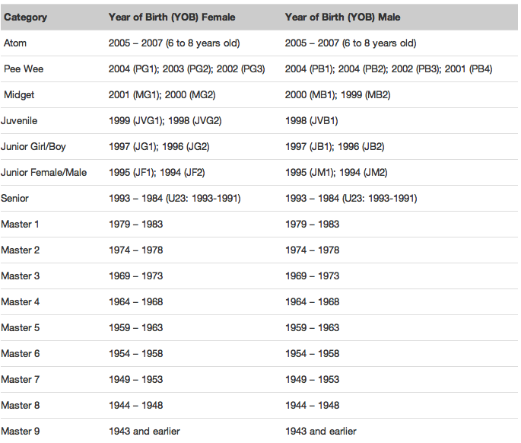

Race Distances: Race Map link here

Sunday Dec. 22nd, 2013  Classic Distance |  | Mass Start Waves in 5 minute intervals @11:00 am
Category | Distance (km) | Mass Start Wave | Course
Junior Men | 12 | #1 | Squirrel Run
Junior Women | 12 | #1 | Squirrel Run
Senior Men (U23) | 12 | #1 | Squirrel Run
Senior Women (U23) | 12 | #1 | Squirrel Run
Masters Men | 12 | #1 | Squirrel Run
Masters Women | 12 | #1 | Squirrel Run

Midget (1 & 2) Boys | 6 | #2 | Boulder
Midget 2 Girls | 6 | #2 | Boulder
Juvenile Boys | 6 | #2 | Boulder
Juvenile Girls | 6 | #2 | Boulder
Junior Boys | 6 | #2 | Boulder
Junior Girls | 6 | #2 | Boulder

Pee Wee Boys | 2.6 | #3 | Jack Pine
Pee Wee Girls | 2.6 | #3 | Jack Pine
Midget 1 Girls | 5.2 | #3 | Jack Pinex2

- Distances are subject to change due to conditions.

Eligibility

All competitors must be a member of a Cross Country Candada club or purchase a ‘Day Licence’ on the Grand Beach Classic Zone 4 registration page for a fee of $5.00.

Registration Deadline

Registration is to be completed only through Zone 4 at http://www.zone4.ca. The deadline for registration is Monday Dec. 16th, 2013 at midnight. NO LATE REGISTRATIONS WILL BE ACCEPTED.

*Entry Fees | Register on Zone 4 by Dec. 16th, 2013
Juvenile, Junior, Senior, Masters | $20
Pee Wee and Midgets | $10
CCC Day License for competitors not registered with a CCC club. | $5
*Entry fees include healthy snack foods, soup, hot/cool drinks, as well as fruit for athletes and coaches.

Starts lists

- Start list for the Race to be posted on Zone 4 by Wednesday Dec. 18th, 2013.

Facilities

- There will be a large heated 30’ x 30’ tent with tables/chairs and food for athletes, coaches and officials. Bathroom facilities will be on site. A waxing tent will be on site.

First Aid

- First Aid will be available on site courtesy of the Canadian Ski Patrol.

